Company X

Use Case 001: CREATE ACCOUNT and SIGN IN

|  |  |
| --- | --- |
| **Date:** | 10/02/2023 |
| **Version:** | 0.1 |
| **Status:** | Draft |

Table of Contents

1 Title: Create Account 4

1.1 Brief Description 4

1.2 Users 4

2 Process Flow(s) 4

2.1 Process Flow: TBD 4

3 Flow of Events 4

3.1 Pre-Conditions 4

3.2 Post-Conditions 4

3.3 Basic Flow: Create Account 4

3.4 Basic Flow: Sign In 5

4 Exception messages 6

5 UI – Create Account 8

6 UI – Login 8

# Title: Create Account

## Brief Description

As a user I want the ability to create account in system so that I can access the system.

## Users

* Actors: Customer/Client/User

# Process Flow(s)

## Process Flow: TBD

# Flow of Events

## Pre-Conditions

* Actor has accessed the website
* Fields with “*” are required fields

## Post-Conditions

* Actor has signed into the system.
* Actor has created an account on the system.

## Basic Flow: Create Account

| **Step** | **Actor Action** | **System Response** | **Notes** |
| --- | --- | --- | --- |
| 1 | Actor Selects “Create New Account” | System displays Create Account page with a button to create a new account. |  |
| 2 | Actor enters account information and select option to create an account  First Name *  Last Name *  Email ID/Username *  Password *  Confirm Password *  Security Question  Answer to Security Question.  Service license agreement *  Click Submit | System will verify that all required fields have been completed and fields contain valid information  **IF Valid:**  - System will create account for actor.  - System will send confirmation email to the user  - System logs actor into system.    **ELSE** - system will display applicable messages for reason why registration cannot be completed or for fields with invalid entries | Refer to section 4. Exception Message for details |
| 3 | Use Case Ends |  |  |

## Basic Flow: Sign In

| **Step** | **Actor Action** | **System Response** | **Notes** |
| --- | --- | --- | --- |
| 1 | Actor selects “Sign In” on the Home page. | System displays “Sign In” page. | When “Sign in” page is displayed, E-Mail address field should display actors last entry if applicable. Password field should be blank/empty.  Focus is in Password field |
| 2 | Actor enters their E-mail address (if not populated by system) and Password in applicable fields and selects “Sign In” | System will validate E-mail address and password.  **If Valid** - system signs actor into the system and shows the last page the actor was on before they signed out last time.  **ELSE** - system will display applicable message for inability to sign actor into system. | Password field keyboard entries will be masked/hidden with bold bullets  System should inform user which fields are invalid.  Refer to section 4. Exception Message for details |
| 3 | This user story ends with success |  |  |

# 

# Exception messages

| **Msg #  (from above)** | **Message** | **Buttons** | **Notes** |
| --- | --- | --- | --- |
| 1 | E-mail address already exists, please enter a different e-mail address. |  | This is in-line message |
| 2 | Invalid e-mail address format. Please re-enter the e-mail address. |  | This is in-line message |
| 3 | Passwords do not match. Please re-enter the password (note password is case sensitive). |  | This is in-line message |
| 4 | Field is required and must be completed. Please enter your information. |  | This is in-line message |
| 5 | To create an account, you must agree to the Service license agreement. |  | This is in-line message |
| 6 | Your account has been created. Click OK to return to the Home Page. | OK | OK - selecting OK will close message and return actor to the Home Page. |
| 7 | E-mails do not match. Please re-enter your e-mail address. |  | This is in-line message |
| 8 | User enters invalid username that system does not recognize. | OK | System displays” You have entered username that system does not recognize” with option to click “OK” |

# UI – Create Account

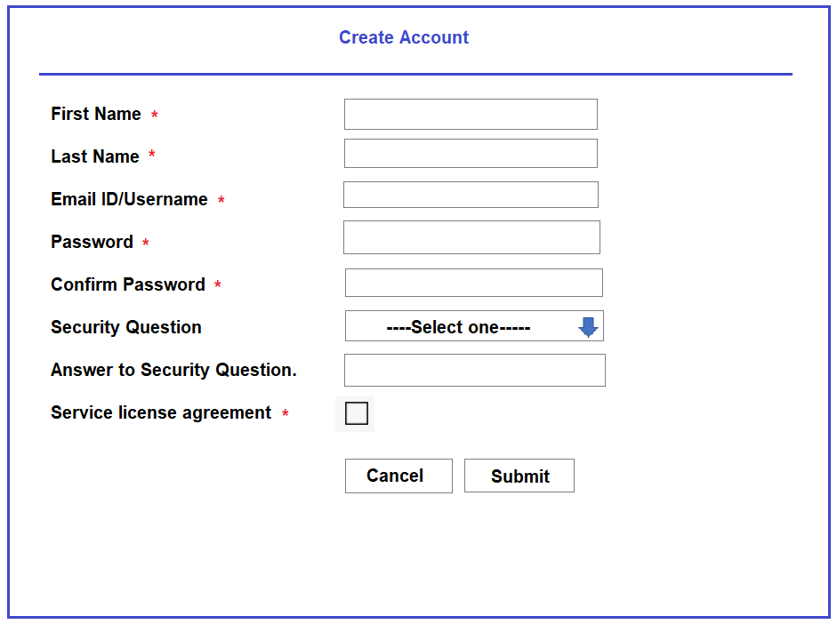

# UI – Login

